Seeing Beyond the Horizon 2016
Sheraton Hotel, Richmond BC
May 2016

Literacy for Individuals with Deafblindness
Presentation Handout

Presented by:

BC Provincial Outreach Program for Students with Deafblindness
- Shelley Law
- Linda Mamer
- Sheila McIntosh
- Allana Pierce

Canadian Deafblind Association – BC Chapter
- Sue Gawne
- Allison Mail
- Theresa Tancock

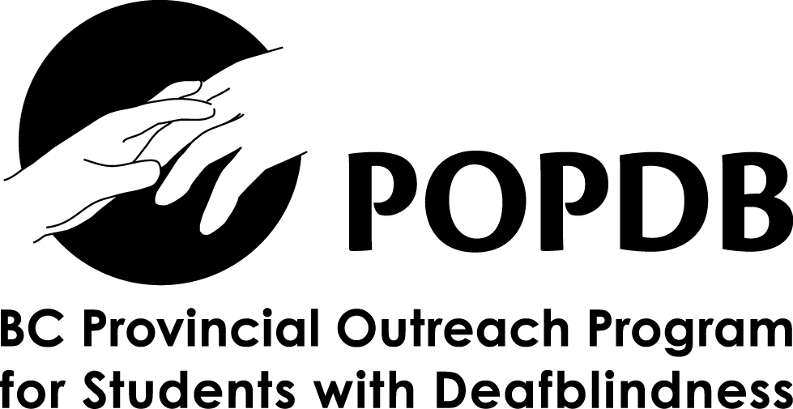

www.cdbabc.ca www.popdb.sd38.bc.ca

Why Literacy?

- Students with significant developmental disabilities CAN learn academic skills and knowledge that was previously not expected
- Literacy and numeracy skills, as well as content knowledge will increase student potential in daily living and vocational opportunities
- Early home Literacy experiences provide important support for the development of language skills
- When parents read to young children, an interaction occurs that supports the development of language
- Emerging research supports teaching literacy to all students including students with significant disabilities
- Literacy is for EVERYONE

Assume EVERY one of your students has the potential for enriching and successful literacy experiences, regardless of how their potential is described
in reports

Reading and writing activities and experiences should not be withheld while waiting for speech, language, motor, or other skills develop

Vicki Rothstein
Early Reading Strategies – Evidence-based Practice for Students with Developmental Disabilities
at the 2015 Summer Institute at the University of British Columbia

Vicki Rothstein’s website: http://bydesigncorp.com/index.html

Definitions:
Deafblindness
Deafblindness is an information gathering disability.
- The person has a combined loss of vision and hearing, such that neither sense can be used as a primary source of accessing information.
- Vision impairment can range from partial sight/low vision to total vision loss and hearing losses can range from mild to profound hearing loss.
- Different combinations of vision loss and hearing loss means that each person with deafblindness experiences it differently and requires specialized intervention.

Each person with deafblindness is UNIQUE. There is no one program that works for each individual who experiences deafblindness. Also, there are often additional disabilities involved.

Consequently, deafblindness has a profound impact on communication, interactions, relationships and learning in a variety of environments.

People with deafblindness need clear, undistorted information in order to understand what is happening around they and to have some choice and control about his life.

Intervention – the process that allows an individual who is deafblind to receive visual and auditory information that she is unable to gather on her own, in a way that is meaningful to her so s/he can interact with the environment. This enables the person who is deafblind to establish and maintain control over her environment.

Intervenor - a person who provides intervention to an individual who is deafblind; a go between, fills in the gaps for the person with deafblindness, is the eyes and ears for the individual with deafblindness.

Role of the Intervenor:
    - Mediate between the person who is deafblind and his/her environment to enable him/her to communicate effectively with and receive, non-distorted information from the world around him/her
    - Act as the eyes and ears of the person with deafblindness

Partial Participation Expanded Participation

Moving beyond “partial participation” – which for its time served its purpose – the concept of expanding participation, helps us think even more inclusively about the level of engagement that we can strive for with our students.

Literacy & Sighted–Hearing Children

For young sighted and hearing children, adults read books to them from birth. Children are exposed to books almost immediately. These books are often read over and over and over with many parents saying “I have read that book – e.g. Goodnight Moon – 1000s of times!”

Children love to have books to read them many times – they love hearing the story and they memorize the story to point where they think that they are actually reading when they go through the book. They are learning book skills and literacy skills through these interactions.

Adults facilitate a love of reading naturally, through natural experiences with books and literacy.

Literacy & the child with deafblindness

Deaf x Blind
Deaf + Blind

The dual loss of vision and hearing complicates learning to read tremendously. While a sighted-hearing child may need to read a book 1000 times to learn it, the child with deafblindness may need to read it a 1000 x 1000 or more to understand the same information.

What about pre-requisite skills?

Often with children with complex needs, including deafblindness, people think about “readiness” or prerequisite skills. These are areas of ability that people believed were necessary for the child to have before starting formal reading and writing.

NOW we look at Emergent Literacy – how literacy develops and we need to have the belief that all children are in the process of becoming literate.

It is a process that involves lots of exposure, repetition, modeling, experience, and natural immersion. Literacy is not merely a pre-requisite set of skills that need to be attained before moving on to the next step. Total immersion to the pleasures and joys of reading is also incredibly important for developing literacy skills.

Vicki Rothstein’s assessment tool:

The Snapshot Assessment:
An Informal Inventory of Early Literacy Behaviours
www.bydesigncorp.com
vickirothstein@gmail.com

The 6 areas that the Snapshot Assessment evaluates are:
- Motivation & Interest in Reading
- Support for Literacy Interactions
- Print Awareness
- Symbol, Letter and Sight Word Recognition
- Phonological Awareness/Decoding
- Reading Comprehension

Description of the stages within the Snapshot Assessment:

- Early Emergent Stage –
    - Just starting to be interested in books, beginning to learn that books can involve interactions between a reader and a literacy partner, beginning to know that books are handled in certain ways
- Later Emergent Stage –
    - Learning about print
- Transitional Stage –
    - Starting to learn the actual skills associated with reading and writing, increased involvement in literacy activities
- Beginning Conventional Stage –
    - Exploring the application of conventional literacy skills while still having support from the literacy partner. Support fades as independence increases
- Later Conventional Stage –
    - Reading connected text from conventional books and the emphasis is becoming more on comprehension

Samples of Literacy with Individuals with Deafblindness

My Notes:

____________________________________________________________________________________
____________________________________________________________________________________
____________________________________________________________________________________
____________________________________________________________________________________
____________________________________________________________________________________
____________________________________________________________________________________
____________________________________________________________________________________
____________________________________________________________________________________
____________________________________________________________________________________
____________________________________________________________________________________
____________________________________________________________________________________
____________________________________________________________________________________
____________________________________________________________________________________
____________________________________________________________________________________
____________________________________________________________________________________
____________________________________________________________________________________
____________________________________________________________________________________
____________________________________________________________________________________
____________________________________________________________________________________
____________________________________________________________________________________
____________________________________________________________________________________
____________________________________________________________________________________
____________________________________________________________________________________
____________________________________________________________________________________
____________________________________________________________________________________
____________________________________________________________________________________
____________________________________________________________________________________
____________________________________________________________________________________
____________________________________________________________________________________
____________________________________________________________________________________
____________________________________________________________________________________
____________________________________________________________________________________
Literacy Resource List

BC Provincial Outreach Program for Students with Deafblindness
http://popdb.sd38.bc.ca/

Best Practices
http://popdb.sd38.bc.ca/Best_Practices

Experience Books
http://popdb.sd38.bc.ca/Experience_Books

Canadian Deafblind Association – BC Chapter
http://www.cdbabc.ca

Canadian Deafblind Association – National
http://www.cdbanational.com

By Design Corp (Vicki Rothstein)
- Vicki’s home page: http://bydesigncorp.com/index.html
- Interests and Preferences Survey
http://bydesigncorp.com/uploads/3/4/3/8/34380371/interests_and_preferences_survey_ubc.pdf

Hand under Hand
- Washington Sensory Disabilities Services - Hand Under Hand Examples: http://www.wsdsonline.org/video-library/deaf-blind-videos/hand-under-hand/
- The Importance of Hands and Touch for Children who are Deafblind (Barbara Miles):
http://www.perkinselearning.org/videos/webcast/reflections-deafblindness-hands-touch
http://documents.nationaldb.org/products/hands.pdf
Paths to Literacy
Paths to Literacy (www.pathstoliteracy.org) is a website with ideas to promote inclusion and friendships for children with deafblindness.
Some examples of what you’ll find are:
- ‘All about Me’ books:
http://www.pathstoliteracy.org/blog/educating-including-deafblind-mainstream-classroom-setting
- ‘Tactile Notes box’ - tactile supplies to encourage classmates to write friendship notes:
http://www.pathstoliteracy.org/strategies/supporting-and-encouraging-friendships

- Supporting friendships – creating ‘Accessible Books’: http://www.pathstoliteracy.org/blog/supporting-friendships-through-creating-accessible-books
- Photo/Video Taking with the iPad: Environmental Conditions and Considerations for the use of the iPad
http://www.pathstoliteracy.org/technology/photo-video-taking-ipad-environmental-conditions-and-considerations-use-ipad

Communication and Literacy
- Bringing literacy into the community: http://www.thejoshuaprojectfoundation.org/TheJoshuaProject.pdf
- Communication Matrix and Resources:
https://www.communicationmatrix.org
- Steps to Literacy: http://literacy.nationaldb.org/files/7614/2907/2212/Steps_to_Literacy_v2015.pdf
- Literacy Skills Checklist: http://literacy.nationaldb.org/files/5813/7591/5452/LiteracySkillsChecklist.FooterAdded.pdf

Journal of Deafblind Studies on Communication
This website focuses on communication and deafblindness from various theoretical perspectives (http://rjhtest.ub.rug.nl/index.php/Deafblindness/index).
Some examples are:
- Narrative Based Conversations:
http://rjhtest.ub.rug.nl/Deafblindness/article/view/3
- Real Space Blend - using gestures and body movement: http://rjhtest.ub.rug.nl/Deafblindness/article/view/18632/16108

Center for Literacy and Disability Studies
This website (https://www.med.unc.edu/ahs/clds/resources/deaf-blind-model-classroom-resources) on Deafblind Model Classroom Resources includes information on shared reading, alphabet activities, remnant books, etc.
Some examples are:
- Top Tools from the Trenches:
https://www.med.unc.edu/ahs/clds/resources/deaf-blind-model-classroom-resources/TopClassroomTools.pdf/view
- Remnant Books:
https://www.med.unc.edu/ahs/clds/resources/deaf-blind-model-classroom-resources/creating-using-remnant-books-for-face-to-face-communication-self-selected-writing

Perkins School for the Blind
This website contains webcasts and information for working with individuals with vision loss and deafblindness – a wealth of information.
Some examples are:
- Teachable Moments:
http://www.perkinselearning.org/videos/teachable-moment
- Natural Conversations with Persons who are Deafblind (Barbara Miles): http://www.perkinselearning.org/videos/webcast/conversations-connecting-and-learning-persons-who-are-deafblind
- Tangible Symbols:
http://www.perkinselearning.org/videos/webcast/tangible-symbols
How I See: CVI
This is an amazing depiction of how an individual with Cortical Visual Impairment sees.
https://www.med.unc.edu/ahs/clds/resources/deaf-blind-model-classroom-resources/creating-using-remnant-books-for-face-to-face-communication-self-selected-writing

