Richmond — The Sheraton Vancouver Airport Hotel demonstrates a new indoor navigation system for people who are blind or low-vision.

This demonstration will be held May 5th through 7th inside the Sheraton Vancouver Airport Conference Centre, located at 7551 Westminster Highway in Richmond, B.C.
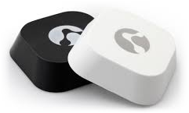
Bluetooth iBeacons, strategically placed throughout the Hotel, will enable visitors who are blind or low-vision to navigate the hotel independently. The battery-operated iBeacons (manufactured by Kontakt.io), which are about half the size of a hockey puck, send out a silent signal 3 – 4 times a second. Once positioning is determined, verbal wayfinding can commence announcing the location of nearby features such as stairs, elevators, exits, restrooms, cafes, and exhibits.
Visitors who are blind or low-vision can access the system using the app BlindSquare - the most used and awarded mobile navigation product for persons who are blind – or the free for the conference, BlindSquare Event.

About BlindSquare
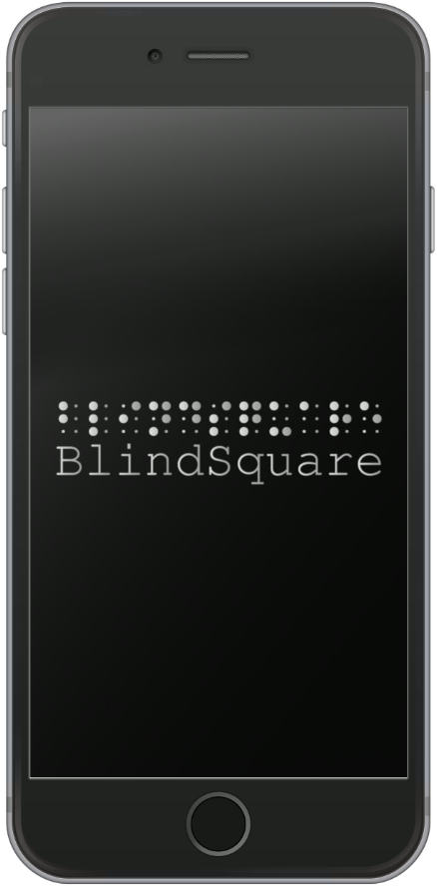
BlindSquare is used in 154 countries and has been translated into 25 languages. Connection to crowd-sourced data, from Foursquare, Open Street Maps and more provides current information on locations, intersections and 60,000,000 points of interest globally. The information is read aloud automatically, so that the user does not have to touch their phone while traveling. When transitioning from outdoors to indoors, where access to GPS Satellites is lost, BlindSquare continues seamlessly using iBeacons to identify location and travel options.
BlindSquare’s Beacon Positioning System (BPS) is an indoor navigation solution first released in May of 2015. Forged from the wants, needs and encouragement of BlindSquare clients globally. BlindSquare BPS has been successfully deployed in locations in Finland, Canada, United States, New Zealand and plans now underway for China, Australia, the Netherlands, Germany, Denmark in venues at Universities, government offices, hotels, transit hubs, museums, performing arts centres, restaurants – each location welcoming visitors who are blind with equal joy.

Attention O&M instructors: Announcing the BlindSquare O&M Project!
1. Receive a BlindSquare license, free of charge to certified O&M professionals.
2. Gain access to a classroom with materials and audio instructions on BlindSquare from an O&M instructors perspective - created and administered by an O&M instructor.
3. Earn continuing education credits required for recertification from both O&M certifying bodies and credit time in support of gathering and providing intersection data for a cloud based repository.

Learn & Share
Visit BlindSquare on the Web at http://blindsquare.com/indoor and enjoy BlindSquare in action at http://bit.ly/ITISmall.
To inquire about iBeacon demonstrations or the BlindSquare O&M Project, please contact
Derek Wilson at 778-215-8695 or via email at derek.wilson@live.com.

